Name: Akil Hosang

ID: 816003000

Course Code & Name: COMP 2606 – Software Engineering

Semester: 2

Year: 2

a)

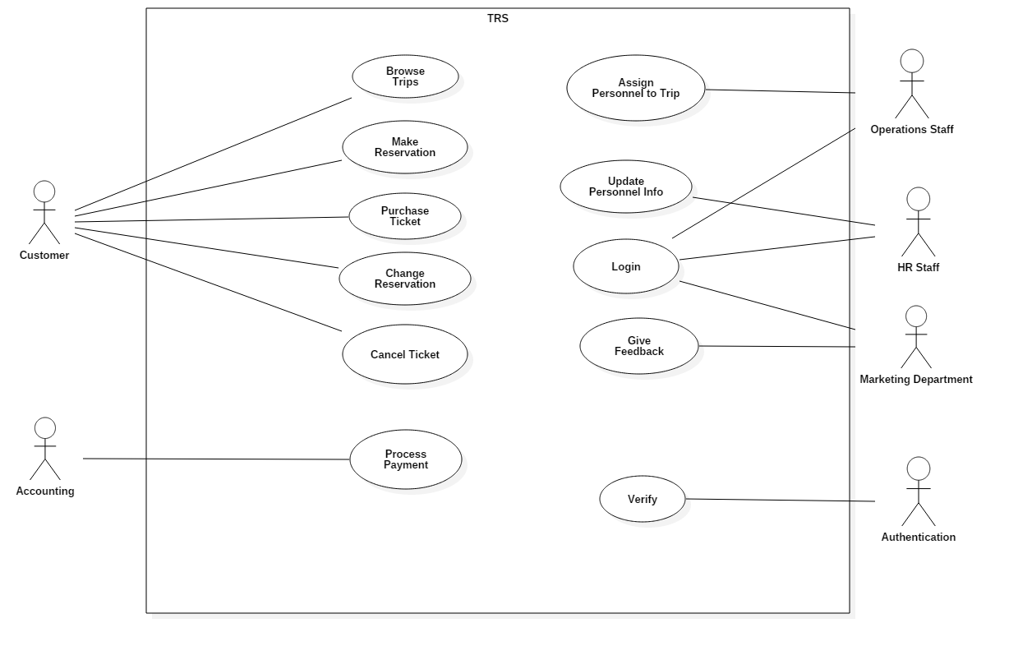

b)

Three goals are:

Security – with transactions being made in this system it’s paramount that customers information are kept secure or else hackers or people with malicious intent can either steal money from cards or even go to peoples’ homes.

Scalability – Due to the nature of transportation, many customers will be interacting with the system to book reservations every day. Thus, the system must be scalable to accommodate these users

Performance – The system must be responsive because the time frame between purchasing tickets may be small and if so the customer needs to have their transactions or other actions completed quickly.

Security and scalability can cause conflict with each other. As a system begins to grow and scale up there is a higher risk due to the larger volume of customer information that has to be secured which derives the issue of conflict between the two goals.

c)

An architectural style that can be used is client-server. This is because the service was meant to be distributed among many hosts over a computer network so the service can be used anywhere.

d)

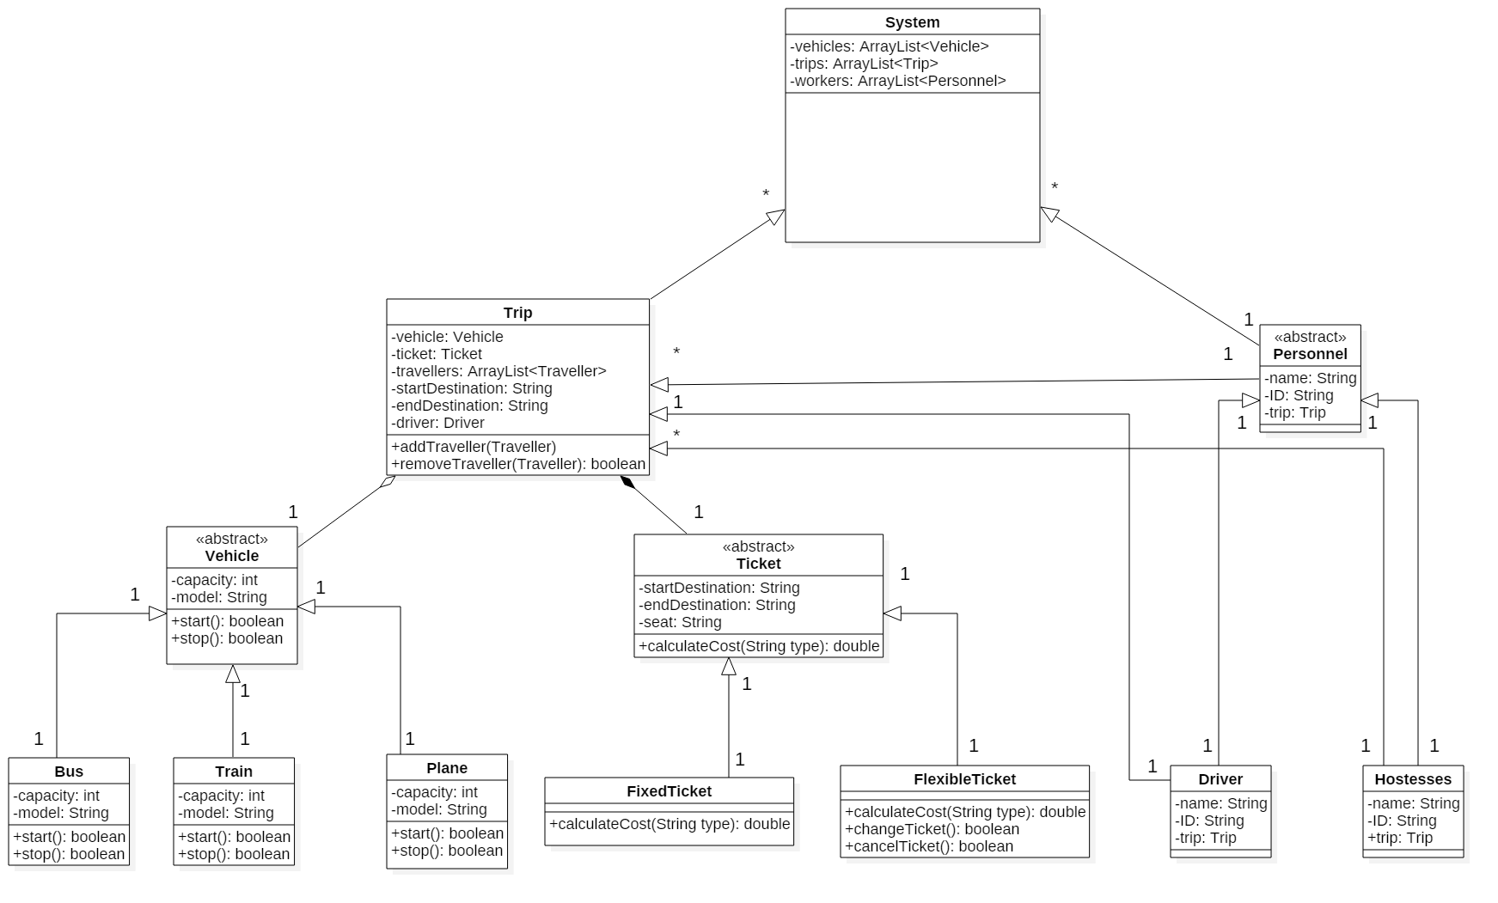

e)

The Singleton design pattern is appropriate for the system because it helps manage the large number of vehicles and trips that would simultaneously be active by giving a single class the responsibility of creation of the object and having only a single object created

The Façade design pattern is appropriate for the system because the user will need to interact with the system and the Façade design pattern provides an interface for the client to access the system and the complexity of the system is hidden from the client.

f) i)

The use cases belonging to this scenario are:

Carlos: Browse Trips, Make Reservation, Purchase Ticket

Accounting: Process Payment

ii)

